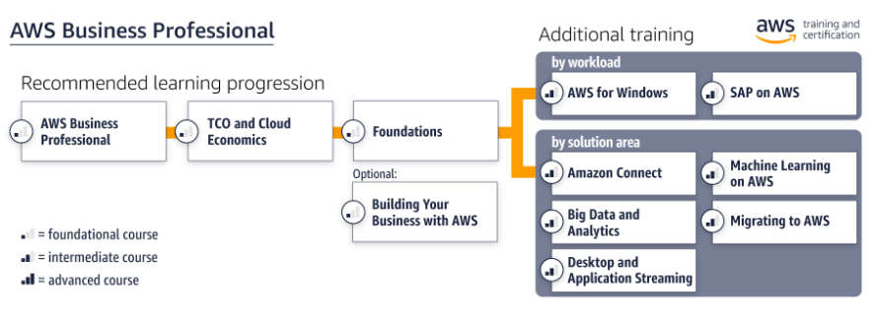

# Functional Training

|  |  |  |  |
| --- | --- | --- | --- |
| Training | Type | Duration | Register |
| AWS Business Professional | Digital | 6 hours | [Register for the digital course](https://partnercentral.awspartner.com/LmsSsoRedirect?RelayState=%2flearningobject%2fcurriculum%3fid%3d11289&src=path-bus-pro) |
| AWS TCO and Cloud Economics | Digital | 3 hours | [Register for the digital course](https://partnercentral.awspartner.com/LmsSsoRedirect?RelayState=%2flearningobject%2fcurriculum%3fid%3d10743&src=path-bus-pro) |
| AWS Solutions Training for Partners: Foundations | Classroom  Digital | 1 day  3 hours | [Find classroom training](https://partnercentral.awspartner.com/LmsSsoRedirect?RelayState=%2ftraining%2fschedule%3fcourseId%3d10010&src=path-bus-pro)  [Register for the digital course](https://partnercentral.awspartner.com/LmsSsoRedirect?RelayState=%2flearningobject%2fcurriculum%3fid%3d13938&src=path-bus-pro) |
| AWS Solutions Training for Partners: Building Your Business with AWS | Classroom | 4 hours | [Find classroom training](https://partnercentral.awspartner.com/LmsSsoRedirect?RelayState=%2ftraining%2fschedule%3fcourseId%3d17079&src=path-bus-pro) |
| Free digital training |  |  | [Start learning for free at aws.training](https://www.aws.training/training?src=path-pro-serv) |

# Additional Workload Training

|  |  |  |  |
| --- | --- | --- | --- |
| Training | Type | Duration | Register |
| AWS Solutions Training for Partners: AWS for Windows (Business) | Classroom  Digital | 4 hours  2 hours | [Find classroom training](https://partnercentral.awspartner.com/LmsSsoRedirect?RelayState=%2ftraining%2fschedule%3fcourseId%3d11565&src=path-bus-pro)  [Register for the digital course](https://partnercentral.awspartner.com/LmsSsoRedirect?RelayState=%2flearningobject%2fcurriculum%3fid%3d11644&src=path-bus-pro) |
| AWS Solutions Training for Partners: SAP on AWS (Business) | Classroom  Digital | 4 hours  2 hours | [Find classroom training](https://partnercentral.awspartner.com/LmsSsoRedirect?RelayState=%2ftraining%2fschedule%3fcourseId%3d14641&src=path-bus-pro)  [Register for the digital course](https://partnercentral.awspartner.com/LmsSsoRedirect?RelayState=%2flearningobject%2fcurriculum%3fid%3d15586&src=path-bus-pro) |

# Additional Solutions Training

|  |  |  |  |
| --- | --- | --- | --- |
| Training | Type | Duration | Register |
| AWS Solutions Training for Partners: Amazon Connect (Business) | Digital | 1.5 hours | [Register for the digital course](https://partnercentral.awspartner.com/LmsSsoRedirect?RelayState=%2flearningobject%2fcurriculum%3fid%3d14027&src=path-bus-pro) |
| AWS Solutions Training for Partners: Big Data and Analytics | Classroom  Digital | 1 day  2 hours | [Find classroom training](https://partnercentral.awspartner.com/LmsSsoRedirect?RelayState=%2ftraining%2fschedule%3fcourseId%3d11566&src=path-bus-pro)  [Register for the digital course](https://partnercentral.awspartner.com/LmsSsoRedirect?RelayState=%2flearningobject%2fcurriculum%3fid%3d11483&src=path-bus-pro) |
| AWS Solutions Training for Partners: Desktop and Application Streaming (Business) | Digital | 2 hours | [Register for the digital course](https://partnercentral.awspartner.com/LmsSsoRedirect?RelayState=%2flearningobject%2fcurriculum%3fid%3d18414&src=path-bus-pro) |
| AWS Solutions Training for Partners: Machine Learning on AWS (Business) | Classroom  Digital | 4 hours  3 hours | [Find classroom training](https://partnercentral.awspartner.com/LmsSsoRedirect?RelayState=%2ftraining%2fschedule%3fcourseId%3d18115&src=path-bus-pro)  [Register for the digital course](https://partnercentral.awspartner.com/LmsSsoRedirect?RelayState=%2flearningobject%2fcurriculum%3fid%3d19692&src=path-bus-pro) |
| AWS Solutions Training for Partners: Migrating to AWS (Business) | Classroom  Digital | 4 hours  1 hour | [Find classroom training](https://partnercentral.awspartner.com/LmsSsoRedirect?RelayState=%2ftraining%2fschedule%3fcourseId%3d16351&src=path-bus-pro)  [Register for the digital course](https://partnercentral.awspartner.com/LmsSsoRedirect?RelayState=%2flearningobject%2fcurriculum%3fid%3d15942&src=path-bus-pro) |